CHILDREN’S ACTIVITIES FOR MOTHERING SUNDAY

These activities work particularly well alongside the talk on
Special love: Exodus 2:1-10
Explore what love is like by using the senses:
Provide a variety of fragrances for the children to smell and ask them what they think love smells like.

Provide a variety of crayons or coloured paper and ask the children what colour they think love is. They could then use their chosen colours when making their cards or bookmarks.

Remind the children that God’s love is both gentle and strong - soft and hard.
Play a game where children take turns in putting their hands into a bag, choosing an item from it and guessing what it is before they take it out. These should be a variety of soft and hard objects. With older children, you could include items for the children to then suggest how they could be used to show love to someone.

If you have a drinks time, provide hard and soft sweets as treat, e.g. marshmallows and fruit drops, as a sweet reminder of the softness and toughness of love.
Remember to check for food allergies

Make gifts for the women in church by filling small containers with a variety of the soft and hard sweets.

Make bookmarks as gifts using this memory verse.
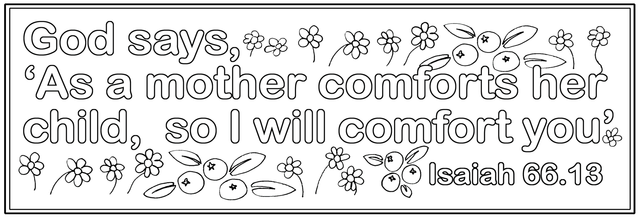

Make “Thank you” cards for mums and carers by decorating the hearts with soft materials e.g. tissue paper or cotton wool, and colouring in the inside text.


Thank you
for your special
love!



These activities work particularly well alongside the talk on
Jesus cares for us: Mark 10:13-16; John 10:10, 14

Tell the children that, like a good shepherd, Jesus not only gives us what we need for a good life but he knows each one of us personally and always recognises our voice.

Play a game where children take turns in covering their eyes in some way while another child calls out baa baa. Can the unseeing child recognise who is calling? The child bleating could start in a whisper then gradually get louder until their voice is recognised.

Use the biscuits from the story for the children to ice and decorate with sprinkles and sweets etc. Share the biscuits with their mums and families.
Remember to check for food allergies

Children can make “Thank you” cards by drawing what their mums like on the bag: e.g. hearts, flowers, smiles, kisses, chocolate....
They can decorate the card, colour in the writing inside and add their name.

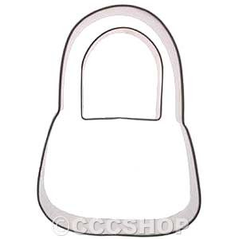

Thank you
for
caring for me!



These activities work particularly well alongside the talk on
The right way to live: Deuteronomy 11:18-20; 2 Timothy 1:5; 3:14

Play “follow my Leader”; Simon Says and other “following” games.
“Simon says” can be adapted so the suggestions are rather good or bad ways to live e.g.
Simon says be kind jump up with thumbs up
Simon says tells a lie crouch down with thumbs down

Children can make the “Thank you” cards by drawing themselves and their Mum/carer on the path and colour and decorate the path and signpost. Inside they can colour in the words and write their name.

Draw a simple picture to colour in of a path and a signpost pointing ahead which says “good life”
Thank you
for showing me
the right way to live



These activities work particularly well alongside the talk on
Give a helping hand: 1 Kings17:8-16; Mark 1:29-34

Cut out paper figures from paper folded as a concertina so they are holding hands. Children can decorate the figures to represent their families and those who are special to them. Older children could write the memory verse on the row of figures as a reminder.

Children can make helping hand cards by drawing round their hand on the front of a folded card and decorating the hand or writing the name of their Mum in it. Inside they can write their name on the dots and fill in how they will help.

..........
will give you
a helping hand
to ...........




These activities work particularly well alongside the talk on
Mothers in the Bible: Exodus 2:1-10

Ice and decorate cupcakes with sprinkles and sweets etc to look like precious jewels. Share the biscuits with their mums and families. Remember to check for food allergies

Colour and decorate “You are precious” cards to give to mums and others who care for the children. Children should write their own name on the dots.

You are precious to ................
and you are precious to God!
Isaiah 43:4



Promise card making activity
When we make a promise we commit ourselves to doing what we’ve promised. As a treat for Mothering Sunday we’re going to make promises to our Mums to thank them for caring for us.

Provide A4 sheets folded in half.
On the cover have printed or write “I promise to....” and on the inside right page draw or print a heart.
Children can draw a picture of themselves on the cover. Children can write their promise inside the heart
e.g. I promise to give you a hug; to tidy my room; to make you a cup of tea; to share my toys with my brother.
Younger children will need help with the writing (or they can draw their promise and a helper can write it).
If time, they can decorate the cards with craft materials. Remind the children to sign their name in the card.

When they have finished you could sit in a circle with the children holding their promise cards, and pray

Dear God,
Thank you for our Mums. Please help us to keep our promise to... encourage the children to either say out or think of the promise they’ve made. Amen

I promise to
...........



Creative prayer activity
Beforehand collect together various props in a bag.
Tell the children that mums play many different and important roles in family life.
Pull out your props one at a time and talk about some of the tasks that mums carry out, or ask the children for ideas.
E.g

Whisk they cook for us
Bandage they look after us when we’re injured
Medicine they nurse us when we’re ill
Car keys they take us to places (to school, church, see our friends)
Washing powder they wash and iron our clothes
Screwdriver they fix things
Storybook they tell us stories
Exercise book they help us with homework
A big paper heart they go on and on loving us, even when we’re naughty

Give out the props to a number of different children and ask them to each say a one-line prayer thanking God that mums do that particular thing for us. Alternatively, say a concluding thank-you prayer yourself, weaving in all the different roles mentioned.



Jigsaw cards

You will need A 5 card; Jigsaw piece templates; Scissors and glue; Coloured paper; Pens and pencils

Fold the piece of card in half and write across the top
Love you to pieces Mum!
Draw round the jigsaw puzzle shapes on coloured paper and cut them out. Stick them onto the card.



Children can plant a bulb in a container as a gift for mothers and carers, which they can then grow together at home. If numbers allow, these can also be given to the rest of the congregation as a gift from the children to their church family.

Make “Thank you” cards for mums and carers by decorating the watering can with images and words to show how they care for their family. You could also have alternative cards for the church family

Thank you...

for helping our family grow well!

Play a version of “Simon says” - “Our family grows well by....” choosing things which either do or don’t help our family, or family of God, to grow well e.g. being kind, helping each other, listening to someone, hogging the tv remote control, arguing....
For attributes that are positive children can make a “thumbs up” for those which are negative, “thumbs down” or sit down.
With older children they may like to take turns to suggest different attributes.

Provide an outline of a tree for them to draw a picture of, or write the names of those who belong to their family. Encourage them to include members of their extended family and people who are like family to them. On the trunk they could write “God loves our family” or for older children a prayer for their family.


